Proposed re-location and conversion of CNES SLR system to South Africa in collaboration with OCA and the greater ILRS community

Introduction

It is proposed that the 1 metre CNES SLR system currently operated by OCA be moved to South Africa for conversion to an SLR/Lunar Laser Ranging System. This new LLR will after successful conversion and refurbishment, be moved from HartRAO (located at Hartebeesthoek) to a suitable new location in South Africa, where eventually, it will be supplemented with collocated space geodesy systems (GPS, SLR2000, VLBI2010, DORIS) to form a node of the proposed IAG Global Geodetic Observing System, termed the International Institute for Space Geodesy and Earth Observation (IISGEO). There is no LLR capability in the southern Hemisphere at present, and the addition of this system to the very small international network of systems capable of LLR will enhance science and open avenues of collaboration with OCA.

We envisage that the global geodetic community will support this project, and support in terms of designs, software and training has in principle been given by several participants in the ILRS such as NASA (GSFC) and BKG (Wetzell). HartRAO currently participates in several IAG networks and supports the IGS, ILRS (operating the NASA MOBLAS6 SLR system) and IVS through geodetic VLBI using a 26 m radio telescope.

If approval is given for the transfer of the 1 metre CNES SLR system, HartRAO will endeavour to source adequate funds for the transportation and refurbishment of the system.

All development, refurbishment and re-commissioning will be done locally in collaboration with the ILRS community and in particular OCA. A site for a new space geodesy observatory (IISGEO) is currently being sought, and several possible sites have been located, from a 3400 m elevation site in Lesotho, the South African Astronomical Observatory in Sutherland (home of the 11m SALT telescope) to a site near a picturesque village in a semi-arid region.

A proposed preliminary time-table is presented here but will obviously be tied to funding in terms of adhering to dates. A five year period is suggested as framework, as this seems to be a realistic period after discussions with other groups (e.g. McDonald Observatory) who have done similar developments.

The project will have strong capacity development components, and will involve several local universities and a number of post-graduate students.

Preliminary refurbishment and conversion time-table

Stage | Month | Description
1 | 0 | Build appropriate temporary shelter for telescope.
2 | 0.5 | Visit OCA and arrange packing/shipping of telescope.
3 | 2 | Import telescope, move it to HartRAO.
4 | 3 | Installation and verification to testable configuration.
5 | 4 | Determine parameters: pointing, encoders resolution, optical efficiency, etc.
6 | 5 | Evaluation of parameters. Alternative solution for improvement.
7 | 6 | Commence design of modification and detailed system drawings.
8 | 8 | Implementation of modification, some of the next items will run in parallel with other sub-tasks.  1. Cablewrap.  2. Encoders.  3. Software.  4. Optics transmit/receive path.  5. etc.
9 | 14 | Commence construction of permanent housing/dome for LLR/SLR at suitable location (site evaluation commenced in May 2004).
10 | 36 | 2 post-grad students at University of Stellenbosch Laser Institute. Commence development of laser. (Students registered January 2005)
11 | 14 | Software and interface development.
12 | 18 | Initial testing of pointing/tracking using upgraded LLR/SLR station and new software.
13 | 24 | Commence integration of laser and timing system with telescope.
14 | 36 | Test phase of LLR/SLR station. Error evaluation, further improvements.
15 | 48 | Place SLR system in operational mode.
16 | 60 | Place LLR system in operational mode.

Finances and Support

The concept of an LLR for the southern Hemisphere has been discussed at the 13th International ILRS Workshop (October 2002) in Washington at an LLR breakaway meeting and was received with enthusiasm by all LLR colleagues. The concentration of LLR systems in the northern Hemisphere adversely affects data reduction and interpretation as all done is sampled in the north, creating biases. We have received several e-mails of support for this project from noted researchers utilising LLR data, as well as support from the Secretary and President of the ILRS.

Support in terms of factors such as scientific collaboration, design, software, training for students and participation in a working group for establishing an LLR in the South Africa have been offered by the NASA SLR network manager (USA), OCA (France), McDonald Observatory (USA), AUSLIG (Australia), GFZ Potsdam (Germany), BKG Wetzell (Germany) and the MLRO (Italy). We have had a close working relationship with many of these groups through our participation in SLR, GPS and VLBI since the early 1980’s.

During the last 2 years, we have been canvassing the support of the National Research Foundation (NRF) of South Africa for this project, and also simultaneously for the establishment of a new space geodesy observatory which would replace the HartRAO space geodesy programme eventually. This project has been approved in principle by the President of the NRF although no special funding has been forthcoming.

The Space Geodesy Programme at HartRAO has some limited funds available, and would for instance be able to source adequate funding for the re-location of the CNES 1 m telescope to South Africa. We have also been funding several students and a post-doc from the Main Astronomical Observatory of Ukraine who are actively involved in certain aspects of the LLR design and development.

The acquisition of the telescope would provide leverage to obtain local and foreign funding through the establishment of an international working group for the development and conversion of the CNES 1 m telescope.

During June 2005, we submitted a funding proposal for the LLR project requested by the NRF, for submission to the Department of Science and Technology.

Partners

With the development of the proposed new space geodesy observatory for South Africa (currently termed International Institute for Space Geodesy and Earth Observation, IISGEO), we envisage a collaborative partnership with several countries and institutions who are already engaged in space geodesy. Once the project is off the ground, which will basically start with the transfer of the CNES 1 m telescope to South Africa, we will engage in a process to solicit partners officially. Some partners have already committed resources in one way or another for IISGEO, e.g., NASA has indicated that they will provide an SLR2000 system for this new station (IISGEO). The LLR will be a main component of the instrumentation sited at the new location of IISGEO and will be developed in collaboration and partnership with OCA and the rest of the SLR/LLR community where appropriate. We also intend to include several other African countries to facilitate the transfer of capacity and knowledge to African universities in support of local and international government initiatives for the development and support of Africa. Although the LLR system will be but a component of this initiative for Africa, the LLR will be synergistically linked to projects such as the development of the African Reference Frame (AFREF) and the African Geoid.

The Observatoire de la Côte d’Azur has shown support for this project and has recognised the benefits to the SLR/LLR community and related disciplines that a southern Hemisphere LLR system would bring to research and science. Specific advantages through collaboration with OCA which a LLR station in South Africa would be able to exploit could include:

- Time transfer by laser link (T2L2) between France and South Africa
- Supporting interplanetary navigation through tracking laser transponder equipped spacecraft
- Simultaneous ranging to the moon (France and South Africa are on closely corresponding longitudes) using synchronized clocks
- Development and implementation of state of the art LLR sub-systems could facilitate future upgrades of the current OCA LLR system
- Sharing of developed software
- Sharing of electronic circuit and hardware development
- Contribution of southern Hemisphere LLR data to ILRS, providing improved LLR products such as produced by the Paris Observatory Lunar Analysis Center
- Exploring high rate data transfers using LASER signals between South Africa and France
- Improved collaboration between South Africa and France in support of the France-South Africa bilateral agreement on Science and Technology
- Opportunities for student exchanges
- Future opportunities for additional CNES involvement with space geodesy and space sciences from South African soil

Background

Ranging to the Moon is possible because of the retroreflector arrays left on the Moon by the American Apollo and Soviet Lunokhod missions to the Moon. Our main goal is to achieve precision of a few picoseconds, corresponding to about one millimeter in range to the Moon. Using this information, we will be able to gauge the relative acceleration of the earth and Moon toward the sun (like a modern-day Leaning Tower of Pisa experiment) in order to ascertain the free-fall properties of earth's gravitational self-energy. LLR also provides the best test of the constancy of Newton's gravitational constant, G, currently limited to a variation of less than one part in 10¹² per year. Relativistic geodetic precession is also best probed (currently) by LLR, now verified at the 0.35% level of precision. And the list goes on: LLR provides the best test of the motional influence on gravitational attraction (called gravitomagnetism) at the 0.1% level, and also sets the most stringent limits on deviations from the expected law of gravity.
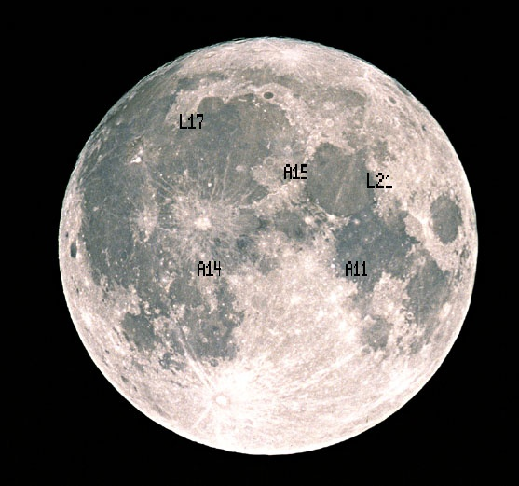
The points of reference for the Earth-Moon measurement will be the earth-based telescope—in this case, the 1 metre telescope at the new station site, and in particular, the intersection of the telescope mount axes—and the small, suitcase-sized retroreflector array placed on the lunar surface by Apollo astronauts. A total of four lunar retroreflectors (Figure 1) are functional: three Apollo reflectors from Apollo 11, 14, and 15 (three times bigger), and one French-built, Soviet landed (unmanned) unit from the Luna 21 mission. A significant part of the challenge of lunar range modeling is converting this point-to-point measurement into a distance between the centre-of-mass of the earth and the centre-of-mass of the Moon. It is only after this reduction that one can consider the interesting part of the problem: the dynamics of the Earth-Moon-Sun system.
Figure 1. Placement of lunar retroreflector arrays.

The LLR system will be designed and built as a dual laser ranging system which will use the same devices for lunar ranging (the main goal), and for low orbiting (up to 1000 km) satellites using so called multi-wavelength laser ranging.
Therefore, the main scientific goals for the proposed LLR are:
- for the Moon: geophysics, selenophysics, celestial mechanics, rotation of the Earth and Moon, precession and nutation, terrestrial and celestial reference frames, test of gravitation theories;
- for the satellites: geodynamics, positioning, comparison of tracking techniques, terrestrial reference frames.
- Time transfer between hemispheres
- Data transfer using LASER

The basic configuration of the LLR system design

The new system will be designed, developed and integrated as a permanent Lunar Laser Ranging System. The multi-wavelength satellite laser ranging will be used to create a model for atmospheric corrections. Such a model, in conjunction with state-of-the-art high precision astronomical, laser and electronics equipment, will allow us to achieve millimeter level accuracy in lunar laser ranging.
The basic features of the LLR System include:

- permanent millimetric lunar laser ranging, day and night;
- multiwavelength satellite laser ranging to create a model of atmospheric corrections;
- single photon mode;
- utmost timing precision;
- utmost mount pointing precision;
- utmost spectral and spatial filtering;
- external and internal calibration;
- autonomous/remote operation.

The LLR system will work in two modes:

  - One-color mode (high energy laser pulses) for lunar laser ranging;
  - Two-color mode (low energy laser pulses) for low orbital (400 – 1000 km) satellite laser ranging.

A schematic diagram of the LLR System is shown in Figure 2. There are a few basic subsystems, of which brief technical configuration and the main software packages are shown. The logic connections between the subsystems and controlling, processing and remote accessing computers are presented.

The LLR System will consist of the following basic subsystems:
- Telescope.
- Laser.
- Photodetectors:
- Start detector.
- Return photons detector.
- Transmit/receive optics.
- Timing and oscillator:
- Time and frequency reference unit.
- Epoch event timer.
- Ranging electronics:
  - Range gate generator.
  - Discriminator.
  - Interfaces.
- Meteoservice.
- Health and safety.
- Shelter.
- Software
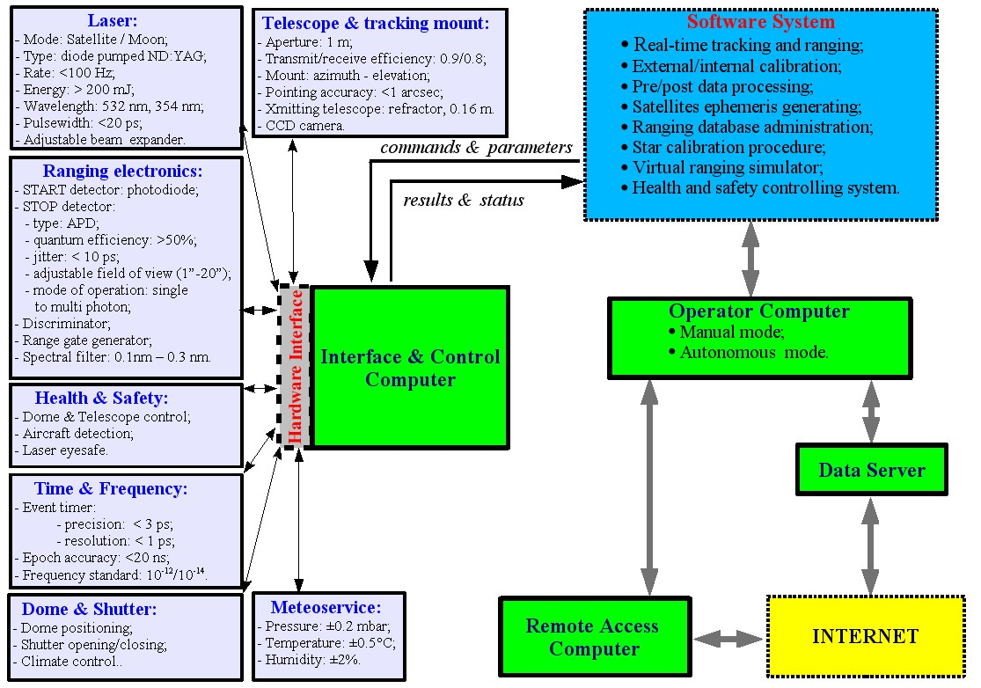
Figure 2. Schematic diagram of the proposed LLR System.

Specifications of the basic subsystems

I. TELESCOPE
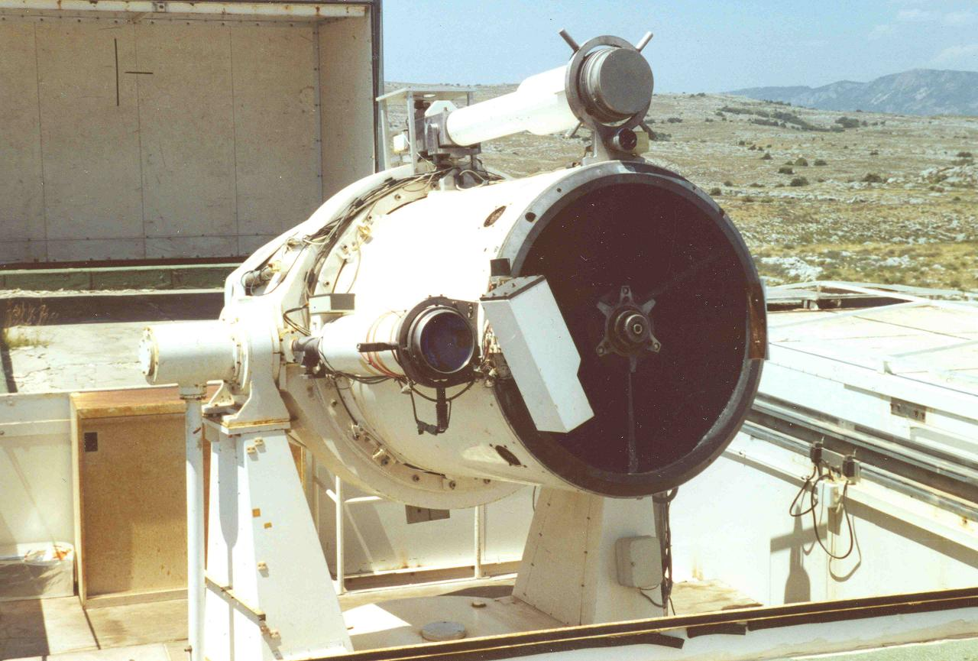

The refurbished CNES 1m telescope will be used to precisely point the outgoing laser beam and to acquire the reflected signals from satellites or the Moon.

The basic configuration of the telescope system is:

Optical configuration:classical Cassegrain with primary mirror and secondary mirror with a convex surface. Light is reflected back through a hole in the primary mirror.

Aperture:1 m;
Transmitting efficiency: >0.9;
Receiving efficiency: >0.8;
Transmit/receivepath: separated;
Transmitting telescope: refractor, ~0.16 m;
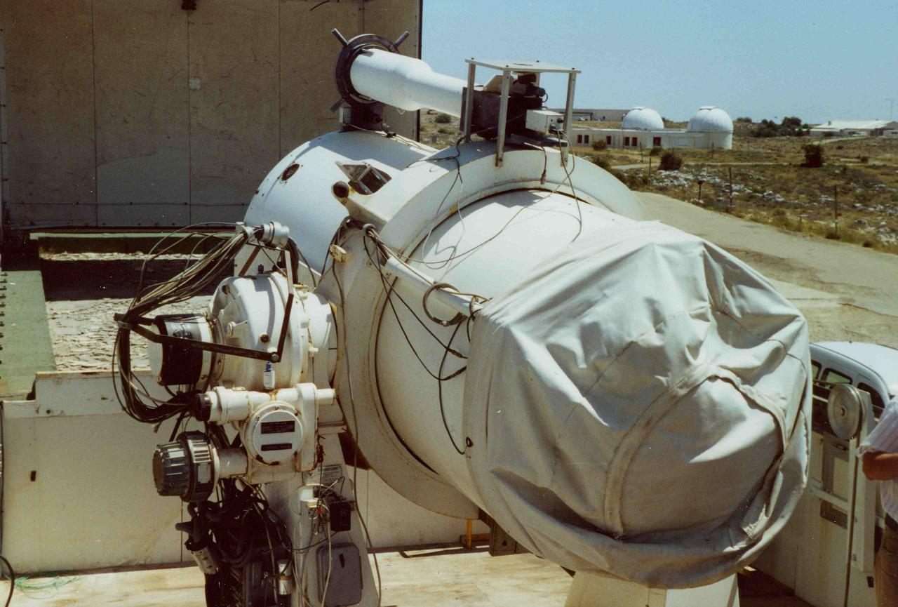
Transmit/receive switch: no;
Tracking camera:CCD;
Mount:Azimuth-Elevation;
Position resolution: <0.5";
Tracking accuracy: <1";
Max slew rate Az, deg/s: 3 deg;
Max slew rate El, deg/s: 3 deg;

> 5;

The telescope system for the LLR site will be fully automated, with high accuracy axis alignment, rigidity, and axis intersection and stability. This will entail re-engineering and enhancements to the current telescope drive and mount to meet higher specifications and new requirements.

The main subsystems of the telescope system are:
stepper drivers;
angular encoders;
tracking camera;
transmitting/receiving path.

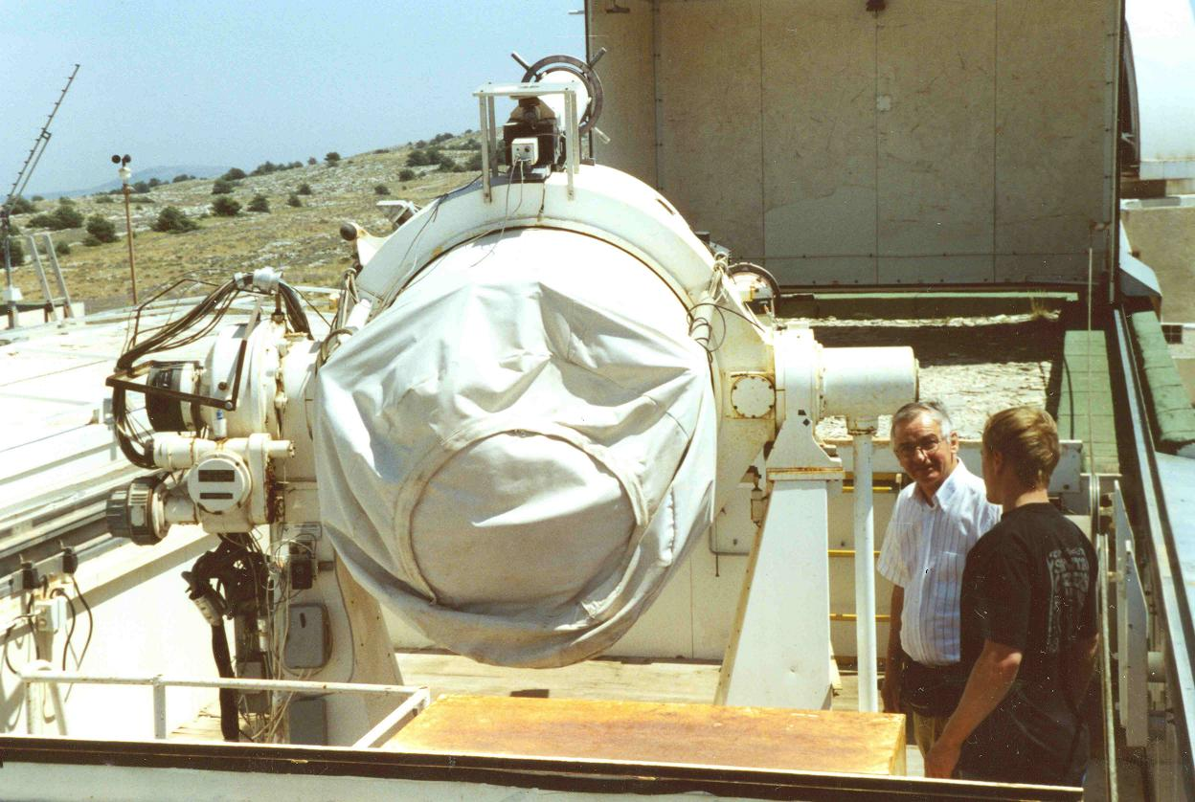

Comparative telescope characteristics of other LLR stations are shown in Table 1.

Table 1. The telescope comparative characteristics of LLR stations.
Name of LLR station | Aperture, m | Transmit/receive efficiency | Tracking accuracy, arcsec | Transmit/  receive path | Max slew rate Az, deg/s | Max slew rate El, deg/s
Grasse, France | 1.54 | 0.45/0.22 | ~3 | Cassegrain, common Coude | 0.5 | 0.5
McDonald Observatory, USA | 0.75 | 0.53/0.38 | 2 | Common Coude | 3 | 3
Apache Point Observatory Lunar Laser-ranging Operation (APOLLO), USA | 3.5 | 0.4/0.25 | <0.5 | Common Coude | >3 | >3
II. LASER

The LLR will be a multi-wavelength laser system. The green wavelength (532 nm) will be used for lunar ranging. Multi-wavelength lunar laser ranging will be virtually impossible because of the very low link budget (~0.01 return photons per pulse). Therefore we are planning to use the second wavelength (probably blue) for multi-wavelength satellite ranging to construct a model of atmospheric corrections for. This will allow one to improve the absolute accuracy of lunar laser ranging to the milli-metre level. Furthermore, some interesting atmospheric investigations can be performed.
The key features that should be considered in the purchase/development of a laser are high power and ultra short pulses.

Proposed configuration.

type: solid state (ND:YAG);
repetition rate: up to 100 Hz for both $λ_{1}$and $λ_{2}$wavelengths;
energy: 200 – 400 mJ/pulse in one-color $λ_{1}$ mode,
20 – 50 mJ/pulse in two-color ${λ_{1}}/{λ_{2}}$mode;
primary wavelength: $λ$= 1064 nm;
secondary wavelengths: $λ_{1}$= 532 nm,
$λ_{2}$= 354 nm;
pulse width: < 20 psec for $λ_{1}$,
< 100 psec for $λ_{2}$;
beam divergence: 1 – 20 arcsec (adjustable beam expander).

Table 2 can be used to compare these characteristics with those of other operational LLR systems.
The laser system would consist of the following basic subsystems:
beam divergence controlling device;
energy adjustable transmitting device;
power supply;
cooling supply.

The beam quality must be such that the atmospheric turbulence ("seeing") will be the limiting factor in overall beam divergence on the way to the Moon.
Finally, the value of $λ_{2}$must be discussed with a manufacturer (the best value in point of view atmospheric absorption and simplicity of design). The value of lunar ranging wavelength $λ_{1}$must be close to green.
Table 2. Comparative laser characteristics of operational LLR stations.

Name of LLR station | Type | Pulse energy, mJ | Repetition rate, Hz | Pulse width, ps | Fullw., beam divergence, arcsec | Final beam diameter, m
Grasse, France | Nd:YAG | 130 | 10 | 250 | 1÷10 | 1.54
McDonald Observatory, USA | Nd:YAG | 1500 | 10 | 200 | 0÷20 | 0.75
Apache Point Observatory Lunar Laser-ranging Operation (APOLLO), USA | Q-switched, mode-locked Nd:YAG | 115 | 20 | <100 | ? | 3.5

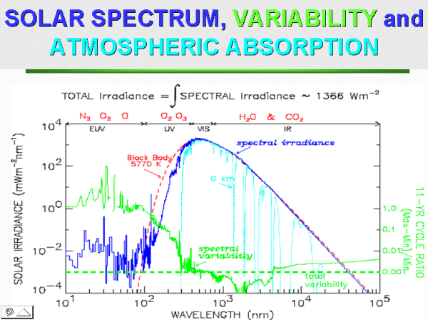
Figure 3. This image, courtesy of Dr. Judith Lean at the US Naval Research Laboratory, shows the spectrum of solar radiation from 10 to 100,000 nm (dark blue), its variability between Solar Maximum and Solar Minimum (green) and the relative transparency of Earth's atmosphere at sea level (light blue). At wavelengths shorter than about 300 nm, there is a relatively large variation in the Sun's extreme UV and x-ray output (greater than 1%), but the Earth's atmosphere is nearly opaque at those wavelengths.
Figure 3 can help us to select the more appropriate laser wavelengths $λ_{1}$and $λ_{2}$with regard to atmospheric absorption.

Possible manufacturers

  - The laser system for the LLR station can be manufactured by the Laser Research Institute, Physics Department of Stellenbosch University, South Africa (www.laser-research.co.za). The Laser Research Institute is a centre of excellence in laser-related research and development in southern Africa. We have placed two post-graduate students at this university, they will work on the development of the LLR laser system and components. This is of course a good choice as it involves capacity building and development of local technology.
  - Raymax Applications Pty. Ltd., which is Australia's premier supplier of laser technology (www.raymax.com.au).
A possible laser configuration delivered by them, would consist of a multi-joule system operating at 50Hz and emits at 1064 nm and has an extremely good beam quality. It is a completely diode pumped system, no flashtubes are required. When configured for 20ps pulsewidth the company can guarantee 300mJ at 532nm.
  - ALPHALAS GmbH is a German source for lasers, optics and electronics (www.alphalas.com).
This company is a manufacturer of picosecond, high energy, low repetition rate laser.

III. PHOTODETECTORS.

The LLR System will require the use of two detectors:
- start pulses detector;
- return photons detector.

Because of the proposed two-wavelength laser ranging it needs to have two return detectors with maximum response in the green and $λ_{2}$ wavelengths. The lunar laser ranging system is a single-photon-counting system. Therefore the quantum efficiency and deadtime of the detector following detection of a “photon event” is extremely important.
Avalanche photodiodes (APD) have long been used as single-photon detectors, operating beyond their breakdown voltage in “Geiger mode”. The detectors, which are a few tens of microns thick, achieve visible photon detection efficiencies in excess of 60%, time resolution in the tens of picoseconds, and have breakdown voltages around 20–40 V [1]. In this mode, a single electron-hole pair generated by an incident photon creates an avalanche of charge that produces a detectable current pulse with rise times of a nanosecond or better and durations of 10–20 ns. The high photon detection efficiency and lower operating voltages make these detectors more favorable than other fast single-photon detectors.

Proposed configuration.

start detector: fast diode;
wavelength $λ$= 1064 nm;
rise time: <50 psec;
jitter: <5 psec;
mode of operation: single/multi photon;
return detectors: APD;
wavelengths: 532 nm, $λ_{2}$ nm;
quantum efficiency: >50%;
nominal gain: >10⁸;
rise time: <50 psec;
jitter: <10 psec;
field of view: 1 – 20 arcsec;
mode of operation: single photon;

Table 3 gives a comparison of the return photon detectors currently in use at LLR stations.

Table 3. The return photons detector comparative characteristics of LLR stations.
Name of LLR station | Type | Quantum efficiency, % | Rise time, ps | Jitter (single PE), ps | Field of view, arcsec | Nominal gain | Manufac-turer
Grasse, France | APD | 20 | 400 | 30 | 7 – 20 | 10⁹ | Silicon Sensor Optic
McDonald Observatory, USA | MCP | 11 | 350 | 100 | 6,10,12,20,35, selectable | 10⁶ | ITT
Apache Point Observatory Lunar Laser-ranging Operation (APOLLO), USA | APD array 4x4 | >50 | <400 | 30 | 1.2 | ? | MIT Lincoln Labs

Possible manufacturers.
  - MIT Lincoln Labs (www.ll.mit.edu) has recently begun exploring integrated APD arrays, with elements arranged in square patterns with 100 µm spacing. The Lincoln Labs designs feature active area diameters ranging from 20–40 µm, with breakdown voltages around 25 V, and photon detection efficiencies upward of 50%.
  - HAMAMATSU (www.hamamatsu.com) is a Photonic Detectors Sources Instruments manufacturing company (sales.hamamatsu.com). Solid State Division of HAMAMATSU produces Si photodiode series: Si photodiode, Si PIN photodiode, Si photodiode array, Si APD, and APD models. The silicon avalanche photodiode (Si APD) has an internal gain mechanism, fast time response, low dark current and high sensitivity in the UV to near infrared region. HAMAMATSU offers Si APDs with active areas ranging from 0.2mm to 5.0mm in diameter. The range of APDs are hermetically sealed in metal packages. Applications for APDs include optical fiber communication, spatial light transmission, low-light-level detection, high speed bar code reader, laser radar and biomedical devices. APD modules that incorporate an APD, power supply and amplifiers are available, as are APD arrays.
  - ThorLabs, www.thorlabs.com.

IV. TRANSMIT/RECEIVE OPTICS.

The T/R optics support the transfer of the laser beam from the laser to the telescope for transmission to the target. The T/R optics also couple the retroreflected signal from the target through the telescope to the detectors in the receiver system. The T/R electronics perform the opto-electronic detection and time measurements associated with each event. The use of dichroic optics allows to get rid of any rapidly moving switch on the optical benches.

Proposed configuration.

- high reflectivity;
- dielectric coatings;
- high damage threshold for pico-second laser pulses.

Possible manufacturers.

- Optical Coatings: Electro Optics System, www.eos-aus.com/coatings.htm.
- ThorLabs, www.thorlabs.com.
- ALPHALAS GmbH (www.alphalas.com).

V. TIMING & OSCILATOR.

To get the best performance from Time-Of-Flight (TOF) devices it is always a good idea/necessary to supply the device with the best high-quality, noise-free external frequency signal that we can. This is because the internal crystal oscillators in timing devices generally have poor long term frequency stability - and any frequency error shows up as a range-dependent error in the range measurement (see Table 4). For the best laser ranging accuracy we need the best frequency stability, and any steps taken to monitor and improve frequency stability will pay handsome dividends.
In SLR/LLR, the station master clock or oscillator, in conjunction with a GPS receiver, provides two important functions. The oscillator not only provides station time, but also provides the timebase (external frequency) to the TOF measurement device. Station time is traceable or steered to US Naval Observatory time via GPS to an accuracy of better than 100 nanoseconds.
There are several different types of oscillators and include crystals, rubidiums, cesiums, and hydrogen masers. The long term (i.e. day, weeks, months) oscillator stability, which is critical in laser ranging, vary considerably (see Table 5). Phase-locking an oscillator to the 1 Pulse Per Second (PPS) from a GPS receiver can enhance the long term ageing effects of crystal and rubidium clocks.
Table 4. Influence of Δƒ₀ /ƒ₀ on range measurement (all units in mm).

Table 5. Long term stability comparison of several types of oscilators.
Long Term Frequency Stability | Crystal | Rubidium | Cesium | Hydrogen Maser
Long Term Frequency Stability | performance range | performance range | performance range | performance range
10⁻⁰⁷ | XXXXXXX
10⁻⁰⁸ | XXXXXXX
10⁻⁰⁹ | XXXXXXX
10⁻¹⁰ | XXXXXXX
10⁻¹¹ | XXXXXXX
10⁻¹² |  | XXXXXXX
10⁻¹³ |  | XXXXXXX | XXXXXXX
10⁻¹⁴ |  |  | XXXXXXX | XXXXXXX
10⁻¹⁵ |  |  |  | XXXXXXX
10⁻¹⁶ |  |  |  | XXXXXXX

Proposed configuration.

frequency standard:
type: Cesium;
short term stability: ≤ 1e-12;
long term stability: ≤ 1e-14;
clock:
epoch accuracy: < 20 nsec.
time reference: GPS;
TOF measurements:
type: epoch timer;
resolution: <1.5 psec;
precision: <3 psec.

The main subsystems of the timing system are:
time service;
frequency service.
TOF measurements service;
Table 6 presents the comparative characteristics of the time and frequency devices in use at LLR stations.

Table 6. The time and frequency devices comparative characteristics of LLR stations.
Name of LLR station | Event timer |  |  | Frequency standard |  |  | Epoch accuracy, nsec
Name of LLR station | Manufac-turer | Precision, psec | Resolution, psec | Manufac-turer | Type | Short/Long term stability, 1e-12 | Epoch accuracy, nsec
Grasse, France | Dassault | 7 | 1.22 | HP | Cesium | 5 / 0.01 | 30
McDonald Observatory, USA | EG&G | ~30 | 50 psec/channel, 4 channels | Austron | Quartz | <10 / <10 | 100
Apache Point Observatory Lunar Laser-ranging Operation (APOLLO), USA | Time-to-digital converter |  |  | ? | ? | ? | ?
 | Phillips Scientific 7186H | 15 | <10

Possible manufacturers

  - An ultra stable event timer was designed at OCA (Observatoire de la Côte d'Azur, www.obs-nice.fr). It includes a vernier, a logic counter, and a 100 MHz frequency synthesis. The event timer has a precision better than 3 ps rms, a time stability better than 0.01 ps over 1000 s and a linearity in the range of 1 ps. The thermal drift of the 100 MHz synthesis has been measured at the level of 0.03 ps/°C. The dead time between two consecutive events is 10 µs. These performances are among the best in the world. A prototype of the device is in operation at OCA. A space design is also under study for the space segment of the Time Transfer by Laser Link Project.
  - Department of Physical Electronics, Faculty of Nuclear Sciences and Physical Engineering of CTU in Prague (http://kfe.fjfi.cvut.cz/~blazej/en/res/prj/pet.html).
Pico Event Timer:
operating principle event timing;
no. of channels 2 or 4 ;
timing resolution 1.2 psec LSB;
timing jitter < 2.5 psec / channel;
stability < 0.5 psec / K , < 0.5 ps /hour;
range gate built in, 20 ns step, up to 1024 pulse "in space";
repetition rate 100 Hz max.
For more detail see http://cddisa.gsfc.nasa.gov/lw13/docs/papers/calib_hamal_2m.pdf.

VI. RANGING ELECTRONICS.

Purpose. Converting transmitted/received light-pulses to electronic-pulses with minimal dissipations in energy and time. Measuring time of detected events. Detected signal processing.
Requirements. High time resolution and precision. High speed and sensibility. Fast interface between the ranging electronics (hardware) and system CPU. Aggressive background noise reduction, fast recovery times.

Proposed configuration.
- range gate generator: electronic device for temporal filtering of return signals;
  - resolution: <20 ps leading edge, <200 ps trailing adge;
  - coarse clock: 250 MHz;
  - RMS jitter: <40 ps;
  - range: 2 ns to infinity;
  - update range: multi-MHz limited by computer interface.
- discriminator: device which is capable of accepting or rejecting a pulse according to the pulse height or voltage. It is utilised for picosecond timing with ultra-fast detectors;
- interfaces: provide connection between the control/proccesing computers and peripheral devices. There are 4 main interfaces that can be chosen for the Lesotho LLR System:
  - Ethernet card: provides connection to the Network. This is the path that the computers use to communicate.
  - CAMAC: CAMAC will constitute the major interface between hardware control computer and the rest of the system. Its plug-in modules provide the signals that allow the computer to "talk and listen" to its peripherals in the other subsystems. The CAMAC inputs and outputs will include digital inputs and outputs, analog-to-digital (A/D) and digital-to-analog (D/A) inputs and outputs, and a high-speed A/D input multiplexer.
  - IEEE: the most popular interface to read data from Time-Of-Flight measurement device.
  - serial interface: RS-232 and/or LPT interface to connect computer with some peripheral devices.

Possible manufacturers.
- Joerger Enterprises, Inc (www.joergerinc.com): CAMAC, VIM.
- Highland Technology, precision electronic instrumentation (www.highlandtechnology.com): CAMAC, VME/VXI Modules, OEM products, MODEL T600 QUAD AMPLIFIER/DISCRIMINATOR.
- ORTEC, http://www.ortec-online.com/index.html: 9327 1-GHz Amplifier and Timing Discriminator (http://www.ortec-online.com/electronics/amp/9327.htm).

VII. METEOSERVICE.

Meteorological errors from SLR/LLR sites have been a common problem in laser ranging, which adversely influence final SLR/LLR data quality. As we push towards 1 – 2 millimetre accuracy, we need to eradicate meteorological errors as an error source.
An error of just 1 millibar induces an elevation dependent range bias of 7 and 3 mm at 20 and 90 degrees elevation, respectively. Furthermore, we cannot neglect the humidity measurement. A 10 % humidity error, at a temperature of 20 degrees Celsius, induces an elevation dependent range bias of 1 and 0.4 millimetres at 20 and 90 degrees, respectively. The impact of a humidity error is temperature dependent, the higher the temperature the larger the error. The temperature measurement is not critical for tropospheric refraction, but is a critical measurement for systems which have remote calibration targets (i.e. calibration distance >1 Km).
The LLR site should have a least one closely located independent meteorological data source (i.e. local airport, weather station, etc.) for comparison purposes. ILRS community recommends that meteorological comparisons be done automatically at least daily and tabulated (i.e. create a database) in order to detect any long term trend in the differences. It is strongly recommended that, at least once every 2 years, the meteorological device be calibrated versus a known standard. This is currently being done within the NASA network and a similar campaign was initiated in 2002 within EUROLAS.
Through regular calibrations and daily comparisons any errors that might creep into the measurements would be traceable and therefore recoverable. Any meteorological data correction algorithms should be sent to the ILRS Central Bureau (cb@ilrs.gsfc.nasa.gov) and footnoted in the LLR site log.
It is also imperative that the LLR barometric sensor either be at the same height as telescope optical axes or that the pressure measurement be corrected for height in on-site data processing. A one metre height difference equates to approximately 0.1 millibar pressure change.
Meteorological devices with ports/gills are preferable to devices with tubing. Tubes can become easily kinked or clogged. Tubing should also be shielded from the wind.

Proposed configuration.

pressure/temperature/humidity:
pressure:
range: 600 to 800 mbar;
accuracy: ≤0.2 mbar;
stability: ≤0.2 mbar/yr;
temperature:
range: -40 to 50 °C;
accuracy: <0.5 °C;
stability: <0.2 °C/yr;
relative humidity:
range: 0 to 100%;
accuracy: ≤2%;
stability: <1%/yr;
precipitation/visibility sensor:
measures visibility: 10 m to 50 Km;
measures type, intensity, and accumulation of precipitation;
all-sky cloud sensor: infrared camera;
wind monitor:
speed:
range: 0 to 325 km/h;
accuracy: < 1.3 km/h;
direction:
range: 0° to 360°;
accuracy: < 5°.

The basic subsystems of the meteorological system would be:
pressure/temperature/humidity monitoring;
wind monitoring;
precipitation/visibility sensor;
all-sky cloud sensor.
Table 7 shows the comparative characteristics of meteoservice at other LLR stations.

Table 7. The meteoservice comparative characteristics of LLR stations.
Name of LLR station | Pressure Sensor |  | Temp Sensor |  | Humidity Sensor
Name of LLR station | Manufacturer | Accurac, mbar | Manufacturer | Accuracy, °C | Manufacturer | Accuracy, %
Grasse, France | Precis Mecanique | 0.25 | Vaisala | 0.2 | Vaisala | 2
McDonald Observatory, USA | Paroscientific | 0.1 | Paroscientific | 0.1 | Paroscientific | 2
Apache Point Observatory Lunar Laser-ranging Operation (APOLLO), USA | ? | ? | ? | ? | ? | ?

Possible manufacturers.

Based on the SLR/LLR site logs, the two most popular manufacturers of meteorological sensors are Paroscientific (16 sites) and Vaisala (6 sites). The Paroscientific MET3 is the most widely used model within the ILRS. Below are URLs of these two manufacturers:

Vaisala Web Site: http://www.vaisala.com/

Paroscientific Web Site: http://www.paroscientific.com/

Paroscientific MET3A description is located at:
http://www.paroscientific.com/met3a.htm

The key features that should be strongly considered in the purchase of any meteorological device for our application are:
1. automated readings,
2. the long term stability and absolute accuracy of the barometric sensor, and
3. rapid humidity recovery time after saturation.

The purchase and proper installation/care of a state-of-the-art meteorological device coupled with periodic calibrations would significantly improve data quality. The cost of a good meteorological device is a relatively small price to pay compared with the total price of an LLR system, especially when considering its potential benefits.
VIII. HEALTH & SAFETY.

The safety system will consist of radar, warning displays, alarms and computer-inhibited operations.
The main purpose of the system is to supply the main operation system with security information about motions, vibrations, smoke or fire. It is used for monitoring the compound, surrounding and dome areas.

Health & Safety would consist of the following subsystems:
video cameras;
motion, vibrations, smoke and fire sensors;
temperature, humidity, water sensors;
remote access.

IX. SHELTER.

Purpose. Protection of the telescope and electronic devices from adverse weather conditions. Maintenance of the integrity of the telescope's optical alignment. Maintenance of the interior climate control.

Proposed configuration.

type of shelter: dome;
temperature and humidity controlling with accuracies: ±2°C, ±10%;
management of rotational movement, dome operating/closing: by a microprocessor based control system;
dome rotation mechanism: servo motors with transmissions and clutches;
an incremental optical encoder for tracking the position of the dome;
manual and computer method for controlling the dome;
a storage battery for the emergency system;
maximum dome speed: >20 °/sec;
number of dome operating motors: 1;
shelter safety to be handled by the Health and Safety computer system;
video cameras, motion sensors, door interlocks, smoke alarms, and vibration sensors must provide security information to the Health and Safety system.

The shelter would consist of the following basic subsystems:
dome rotation mechanism;
safety system;
system for emergency closure of the shutter;
movement controlling system;
interior space for telescope, laser, ranging electronics, operational computers.

Possible manufacturers

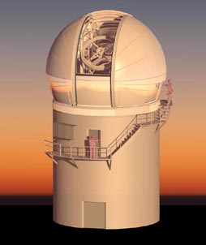

Electro Optic Systems (EOS, Australia) provides a complete, turnkey observatory design, installation, commissioning and maintenance service to the astronomical, satellite laser ranging and defence communities.
Design and construction may be turnkey or a co-operative effort between EOS and the customer's architectural team.
Standard or custom telescope enclosures can be combined with EOS' proprietary retained form work constructions system and prefabricated building modules to create a cost effective observatory optimised for the LLR site.
EOS uses prefabrication and assembly techniques to reduce site time (and cost) and to allow off-site fabrication of observatory components.
Ancillary equipment can be provided either from standard design or for the particular application. Packaged rooms and workshops, cooling systems for telescope thermal control, meteorology sensors (including sky cameras), vacuum systems and light pipers for interferometry, ventilation systems and mirror handling/coating systems are all available as part of an EOS turnkey system.

The EOS Technologies company (www.eostech.com) provides IceStorm series enclosures:
- Standard model in series is suitable for telescopes up to 2.6 metres in aperture;
- Co-rotating, 9 metre spherical enclosure;
- Up-and-over dual mode shutter;
- Integrated insulated equipment room and 2 ton crane.

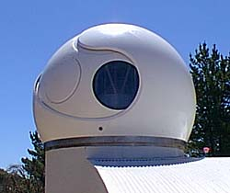

Optical applications often require deployment of valuable telescopes and optical sensors in remote or harsh environments. At the same time, efficiency requires automated operation and advanced seeing control strategies for optimising instrument performance. The TYPHOON dome is a 2-axis weatherproof (optionally dustproof) dome designed for unattended operations in harsh environments. It can support traditional (ventilated) seeing control, or effectively allow full thermal control of the telescope.
The features of the TYPHOON dome are:

- Suitable for telescopes from 0.75 metres to 8 metres;
- Advanced composite shell with high strength to weight ratio;
- Extreme environment specifications (wind, snow, ice and earthquake);
- Ultra low vibration for enhanced telescope stability;
- Unmanned (remote) operation, fail-safe vent and shutter closure;
- Optimised thermal performance through insulated composite shell;
- Fully integrated with telescope and observatory software via LAN;
- Modular construction for minimum site costs;
- Manufactured to ISO 9000 standards and fully tested before delivery;
- Lifetime support contracts available;
- Standard production models or fully custom designs

The following describes a few projects that EOS or EOST have worked on over the years:
Geoscience Australia - Mt Stromlo SLR Observatory
http://www.auslig.gov.au/geodesy/slr/stromlo/index.htm
Keystone Project, Japan
http://ksp.crl.go.jp/index.html
MAGNUM Telescope, Haleakala, Hawaii
Research Center for the Early Universe, The University of Tokyo
http://merope.mtk.nao.ac.jp/~yuki/magnum_hp/telescope.htm
Mauna Kea Observatories, Hawaii
http://www.ifa.hawaii.edu/mko/maunakea.htm
W.M Keck Observatory, Mauna Kea Hawaii
Keck Interferometer with four 1.8-m outrigger telescopes
http://huey.jpl.nasa.gov/keck/publicWWW/techdesc/
X. SOFTWARE.

Purpose. The software package should provide effective and reliable operation and control to the ranging system. Also, it must maximally automate such complex procedures as interfacing to the hardware, ranging data collecting and processing, measurements calibrating, and object tracking by the telescope.

Requirements. Ability to work in a real-time mode. High stability to crashes. Modularity and good capability for upgrades.

Proposed configuration.

fast interface to hardware devices;
capability to work in a real-time mode (some parts);
intuitively understandable and friendly design of the Graphical User Interface (GUI);
capability to work with Internet connection;
fast mathematic algorithms;
maximum autonomous work;
access to a database via web sites;

The LLR software package will consist of three basic parts:

  - The real-time control and data acquisition subsystem.
  - The non-real-time data processing and analysis subsystem.
  - Windows Graphical User Interface subsystem.

The LLR operating software should use at least 4 main library units:

1. Drivers for connecting to hardware components.
2. Mathematic library.
3. GUI.
4. Administration of the ranging database.

The basic components of the LLR software package should include:
object tracking by the telescope;
object ranging procedure;
external/internal calibration of the measured distances;
star calibration for mount pointing;
pre/post data processing;
computation of schedule;
on-site normal points generation;
remote access system;
virtual ranging simulator;
health and safety system controlling;
ranging database administrating;
data sending/getting to/from a Data Processing Center.

The list of proposed operating systems which can be used for executing the applications, include:

- LynxOS real-time operating system;
- Windows NT;
- Linux.

Possible manufacturers

  - The EOS Technologies company (www.eostech.com).

REFERENCES.
[1]. Cova, S., Ghioni, M., Lacaita, A., Samori, C., & Zappa, F., “Avalanche photodiodes and
quencing circuits for single-photon detection”, Applied Optics, 35, 1956, (1996).
[2]. Degnan J.J., “Millimeter Accuracy Satellite Laser Ranging: A Review.” Geodynamics Series 25.
[3]. Faller J.E., 1972, Space Res. XII, 235.
[4]. Fournet M., 1972, Space Res. XII, 261.
[5]. Herring T.A., 1992, in: Munck J.D. and Spoelstra T.T., “Refraction of Transatmospheric Signals in Geodesy”, p. 157.
[6]. Marini J.W., Murray C.W., 1973, Nasa GSFC, X-591, 73.

